

**Course Mathematics Specialist Year 12**

Student name: ________________________ Teacher name: ________________

Date: 28 June 2021 [Monday, Week 11]

**Task type: Take home – Investigation – Volume of solids of revolution**

**Time allowed for this task: 2 weeks**

**Number of questions: 6**

**Materials required:** Calculator with CAS capability (to be provided by the student)

Standard items: Pens (blue/black preferred), pencils (including coloured), sharpener, correction fluid/tape, eraser, ruler, highlighters

Special items: Drawing instruments, templates, notes on one unfolded sheet of   
A4 paper, and up to three calculators approved for use in the WACE examinations

**Marks available: N/A**

**Task weighting: N/A**

**Formula sheet provided: Yes**

**Note: All part questions worth more than 2 marks require working to obtain full marks.**

**INSTRUCTIONS**

1. Take-home section and classpad will be allowed in the in-class investigation.

2. Your CAP is on Wednesday, Week 1, Term 3. It will be 40 minutes long.

Take-home section is in 2 parts:

Part A: Introduction to mathematics required to complete Part B.

Part B: Choose an object or design and 3D print a solid, obtained by rotating a region about the fixed line and calculate its volume using estimation and mathematics.

**PART A – Formulae for the volumes of solids of revolution**

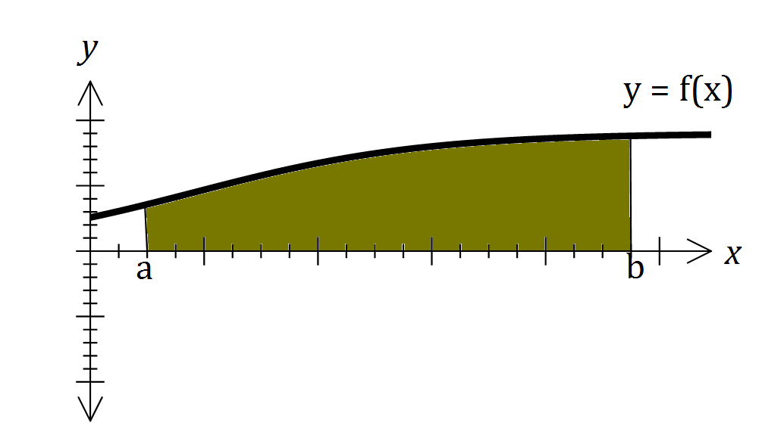

In general, for any given function, the volume of the solid of revolution (i.e. the volume of the 3-dimensional solid formed by rotating the graph of the function about the *x*-axis) is given by the integral expression:

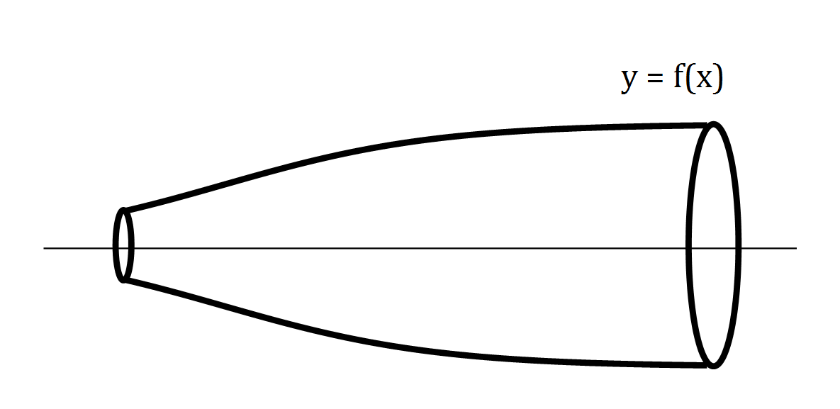

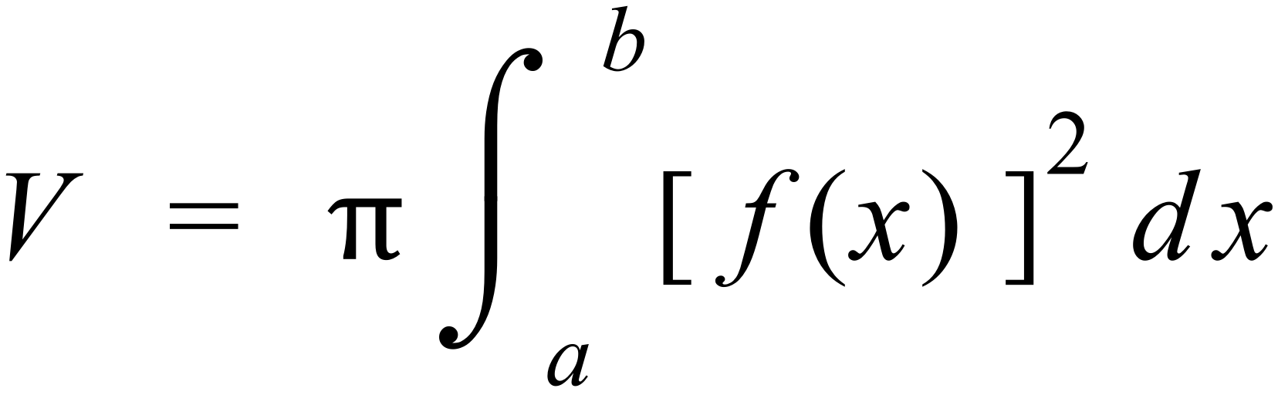

Similarly, the volume of the solid of revolution (i.e. the volume of the 3-dimensional solid formed by rotating the graph of the function about the *y*-axis) is given by the integral expression:

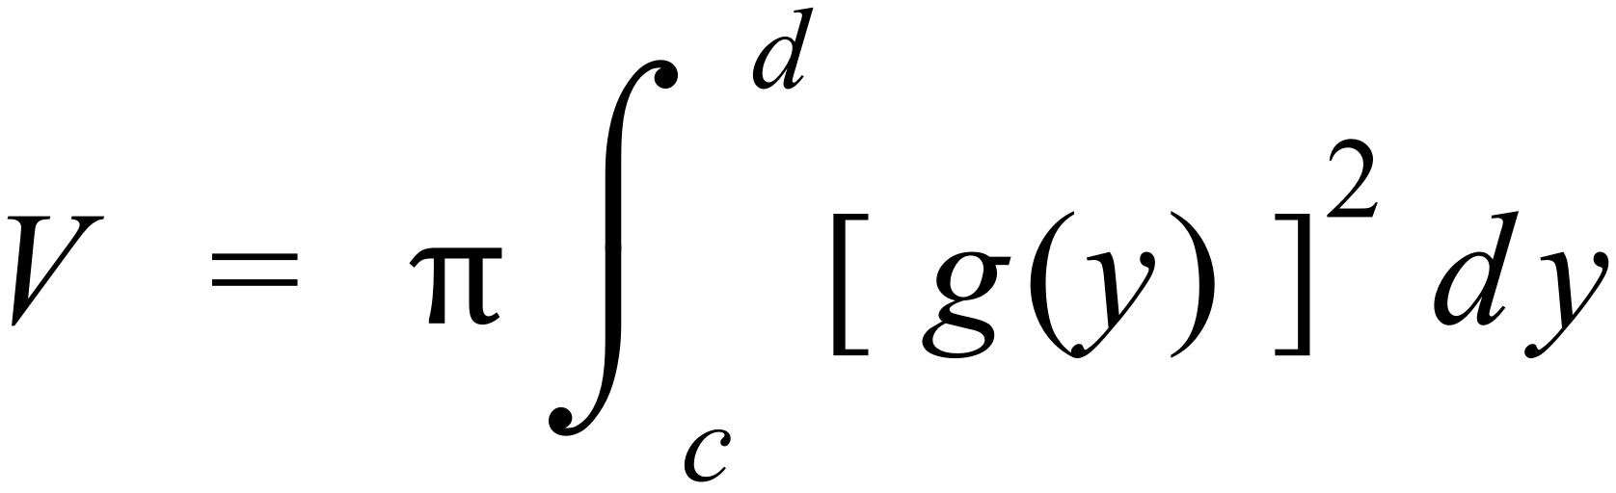

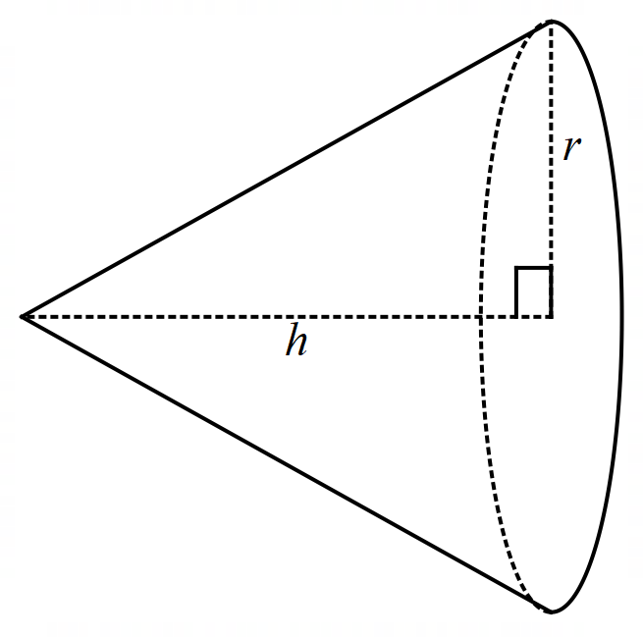**Question 1.**

Use calculus techniques to complete the proofs below.

1. Prove that volume of a cone is $\frac{1}{3}πr^{2}h$.

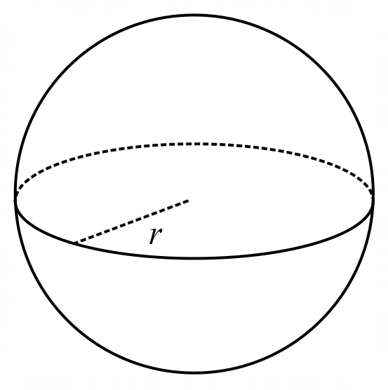

1. Prove that volume of a sphere is $\frac{4}{3}πr^{3}$.
2. Prove the volume of a conical frustum is

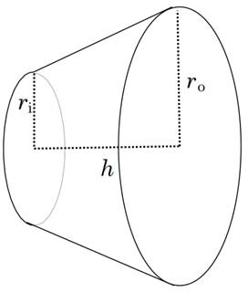



**Question 2.**

Kira has been doing Mathematics Specialist course.

She decided to check how effective it would be to model the outside shape with an equation and then calculate the volume.

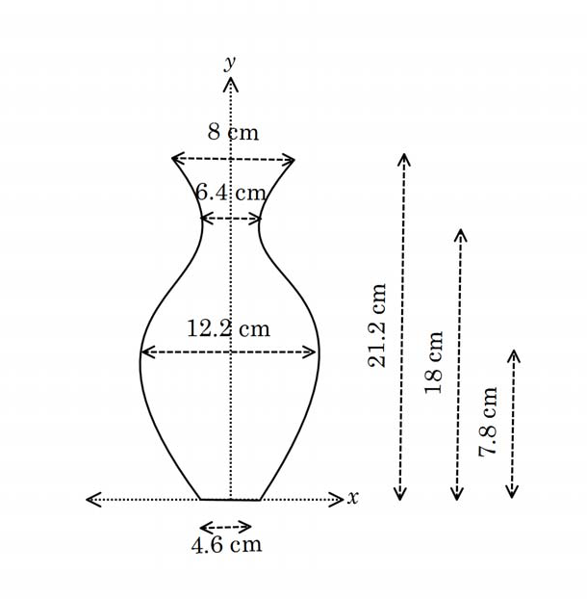She measured the internal volume by determining the volume of water required to fill the vase.

Internal volume: 1330 cm3

1. Complete a table of values using Kira’s measurements.

Use the axis of symmetry as the *y*-axis and the base as the *x*-axis.

|  |  |  |  |  |
| --- | --- | --- | --- | --- |
| *y* | 0 |  |  |  |
| *x* | 2.3 |  |  |  |

1. Determine a cubic equation for ***x* as a function of *y*** to the curve using your

data from the table in Q1. (You can use regression to model your function. **See page 6**)

1. Determine the volume of the vase using calculus.

(That is the external volume including the glass and internal space.)

1. Use internal volume and your answer to c) to estimate the volume of glass in the vase.
2. Estimate the average thickness of the glass in the sides. (Assume there is no base)

**PART B**

You can choose between the two options given below.

Option 1 -

Your task is to choose an object in your home and use calculus to estimate the space within the object. You should also use another method of estimation to verify the answer achieved by your mathematics.

The object you choose can be any object from your home; a vase, a lampshade, a wine glass or another object for which you can map the shape of one side and find a function or functions that model the curve made by the outside edge of the object.

You may need to lay the object on its side to get a function you can easily model.

* Estimate the volume of the object using mathematical methods
* Explain how you developed and checked your estimation. Include mathematical working, written explanation, graphs, photographs, diagrams and any other means that you deem appropriate to support your explanation.
* Find a non-calculus method of estimation to check your mathematical value. Compare the accuracy of your methods.
* Discuss ways in which errors (could have) occurred and how they could be minimised.

Option 2 –

Design a 3D object using a function or functions that model the outside edge of the object.

You can also 3D print your object.

* Estimate the volume of the object using mathematical methods
* Explain how you developed and checked your estimation. Include mathematical working, written explanation, graphs, photographs, diagrams and any other means that you deem appropriate to support your explanation.
* Find a non-calculus method of estimation to check your mathematical value. Compare the accuracy of your methods.
* Discuss ways in which errors (could have) occurred and how they could be minimised.

Watch following videos to visualise and design your objects.

1. Using GeoGebra to visualize solids of revolution for calculus

<https://youtu.be/PI4C5CQkBiQ>

1. How to make a custom solid of revolution in GeoGebra

<https://youtu.be/5wOtyT86Qhw>

**Learning notes**

Q2 b) Use statistics

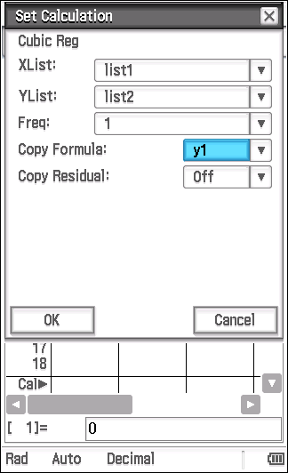

**Determine function using a regression**

* Open Statistics app
* Enter the data from the table

y-values in list1 and x-values in list2

* Select [Calc | Regression | Cubic Reg]
* Settings shown will give x as a function of y
* Tap OK
* Tap to view the graph.

It should look like half the vase on its side.

* Record the equation.